Stacy Hennen, Director

*Western Prairie Human Service Summary Report 2022*

2022 in Review

2022 was Western Prairie Human Services (WPHS) first year as a joint powers’ agency serving Pope and Grant Counties. WPHS is delegated to complete all of the human services functions of the counties that are members and is ran by a board made up of ten county commissioners, five from Pope County and five from Grant County.

This is a shortened summary of all the services performed in 2022, the full report with more detail will also be available to the public on our website. WPHS staff worked hard to serve the people of our counties and overall served the following:

* Served **50,836** people on medical assistance
* Issued **$3,161,437** in Supplemental Nutrition Assistance Program (SNAP) Benefits in 2022
* **42** childcare providers received Childcare Assistance Program (CCAP) payments in 2022
* Collected **$1,612,856** in child support for custodial parents
* We received **529** child protection intake and assessed **156** of those with neglect making up our largest category at **66%.**
* We had **130** child welfare intakes and **44** Parent Support Outreach Program (PSOP) intakes in 2022 with **43** referrals were made for cases.
* We served **99** children through children’s mental health targeted case management and had zero residential placements. We did have **4** families utilize our grant pilot program, Community Intensive Bridging Services (CIBS), meant to prevent long term residential out of home placement by strengthening families with more intensive in-home services for the child and family.
* We served **77** adults through our adult mental health targeted case management and had **4** commitments
* We served **115** people through the developmental disability waivers and
* We had **117** adult protection reports and accepted **45** of them for assessment
* We have **17** adult foster care homes licensed and **27** child foster care homes licensed.
* We had an unmodified audit opinion for our 2022 audit completed by the State Auditor
* Through case management we brought in dollars that helped us offset levy dollars, along with a federal match for much of what we do. The dollars were the following
  + Targeted Case Management: **$1,016,525.28**
  + Waiver billing: **$289,845.30**

Our 2022 budget was **$8,686,371.40** and we ended the year at 106% revenue and 96% spent. As a result, we ended our year in our cash budget to the positive of **$812,239.72**. That is not with expenses or revenues for that year that came in 2023, but reflects our cash balance at the end of December.

The Western Prairie Human Services Board and Staff worked hard to help make our first year a success and we look forward to continuing to serve the people of Pope and Grant Counties

***Income Maintenance 2022***

* 2022 Annual Summary page 1
* Index page 2
* Medical Assistance/ Emergency General Assistance page 3
* SNAP/ Provider Registrations page 4
* Fraud page 5
* Child Support/ Paternity page 6

***Child Protection Unit***

* Child Protection Screen -Ins by Allegations page 7
* Timelines to initial contact page7
* Western Prairie Caseloads page 8
* Parental Substance/Chemical Use/Permanency page 9
* Federal/State Performance Measures page 10

***Children and Adult Mental Health Unit***

* Caseloads for WPHS page 11
* Commitments/Placements page 12

***Adult Services/Developmentally Disability Unit***

* Case Management page13
* Waiver/Investigations page 14
* Adult Protection/Foster Care/ Licensing page 15

***Fiscal Unit***

* Mental Health Targeted Case Management/Waiver page 16
* Child Welfare Targeted Case Management/VADD page 17
* WPHS Expenses page 18
* Budget page 19

Medical Assistance

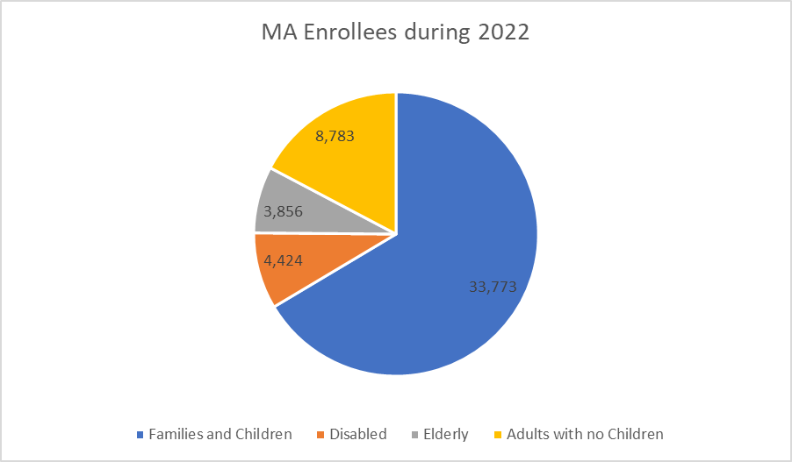

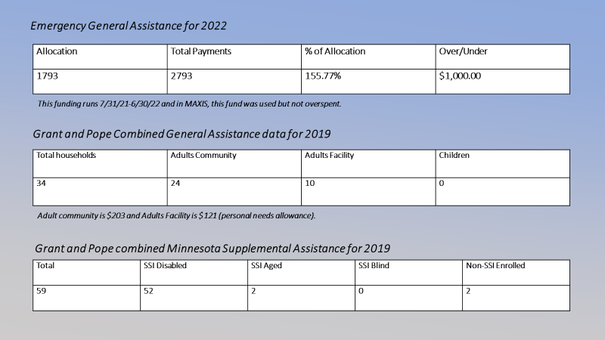

***WPHS issued $3,161,437.00 total for 2022 in SNAP in comparison to the state total of $1,230,583,258***

*Provider Registrations for Western Prairie Human Services*

***The pie chart represents WPHS total providers and is broken down by provider types***

***Fraud***

***Child Support Unit***

|  |  |
| --- | --- |
| ***Collections*** | ***$1,612,856*** |
| ***Income with Holding*** | ***$1,151,277*** |
| ***Re-employment*** | ***$28,828*** |
| ***Federal Tax*** | ***$81,636*** |
| ***State Tax*** | ***$16,795*** |
| ***Other States*** | ***$82,177*** |
| ***Other Counties*** | ***$0*** |
| ***Other Sources*** | ***$245,177*** |
| ***FDIM*** | ***$17,780*** |

|  |  |  |  |  |  |  |
| --- | --- | --- | --- | --- | --- | --- |
| **Case Count beginning FFY2022** | **New cases added FY2022** | **Cases reopened FFY2022** | **Cases closed FFY2022** | **Total case transactions FFY2022** | **Case count end FFY2022** | **Case count change in FFY2022** |
| **300** | 34 | 9 | 84 | 127 | 474 | 58.0% |

|  |  |  |  |  |  |
| --- | --- | --- | --- | --- | --- |
|  | **FFY2022 (%)** | **FFY2021 (%)**  **Pope/Grant** | **FFY2020 (%) Pope/Grant** | **FFY 2019 (%)**  **Pope/Grant** | **FFY 2018 (%)**  **Pope/Grant** |
| **Paternities Established** | **98.25** | **100.85/91.71** | **105.58/102.34** | **99.61/107.14** | **100.76/95.03** |
| **Orders Established** | **94.29** | **92.31/93.87** | **93.44/88.19** | **95.86/96.09** | **95.76/95.34** |
| **Collections on Current** | **77.45** | **77.69/80.67** | **80.76/83.13** | **78.54/82.71** | **79.37/83.67** |
| **Collections on arrears** | **72.47** | **75.20/77.14** | **82.12/86.89** | **79.31/80.10** | **77.55/80.00** |
| **Cost effectiveness** | **3.57** | **3.24/3.10** | **4.58/2.69** | **4.22/2.88** | **3.98/3.22** |

***Child Protection Unit***

|  |  |  |  |  |
| --- | --- | --- | --- | --- |
| *WPHS-By Allegations* | *2019* | *2020* | *2021* | *2022* |
| Total CP intakes Received | 492 | 482 | 514 | 529 |
| Total CP Cases Screened In | 198 | 192 | 147 | 156 |
| Mental Injury | 18.2% | 15.1% | 19% | 13.5 |
| Neglect | 68.2% | 66.1% | 62.6% | 66% |
| Physical Abuse | 23.7% | 19.8% | 22.4% | 25% |
| Sexual Abuse | 8.6% | 10.9% | 10.9% | 11.5% |
| Threatened injury | 22.2% | 15.6% | 21.8% | 23.1% |
| Assessed reports flipped to case management | **45** | **47** | **39** | **28** |

|  |  |  |  |  |  |
| --- | --- | --- | --- | --- | --- |
| WPHS Federal Measures | 2019 | 2020 | 2021 | 2022 | Performance Standards |
| Maltreatment Recurrence | 18.6% | 23% | 8.3% | 10% | 9.1% or Less |

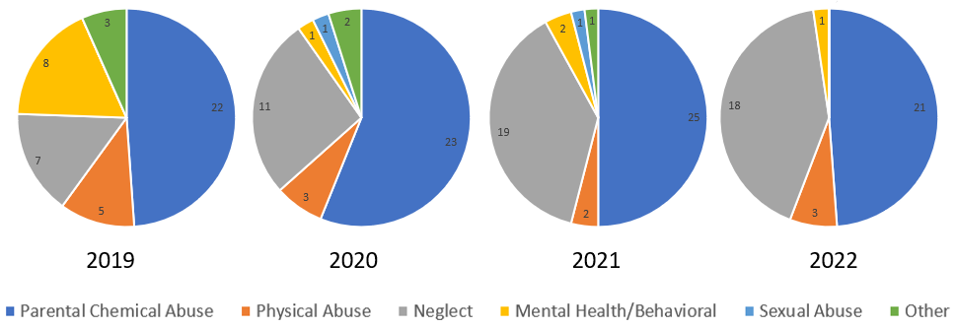

|  |  |  |
| --- | --- | --- |
| **Permanency Track under Child Protection (42)** | **Successful** | **On Track for success** |
| Reunification with parents/primary caregiver | 14.3% | 9.5% |
| Transfer/residing with non-removal parent | 0% | 4.8% |
| TPLPC to Relative | 4.8% | 14.3% |
| Adoption to Relative | 2.4% | 4.8% |
| Adoption to Non-relative | 9.5% | 9.5% |
| Aged Out | 4.7% | 2.4% |
| Permanency Undetermined | n/a | 19% |

*Federal/State Performance Measures*

|  |  |  |  |  |  |
| --- | --- | --- | --- | --- | --- |
| WPHS-Federal Measures- Permanency Timelines | 2019 | 2020 | 2021 | 2022 | Performance Standard |
| Permanency: 12 months | 61.1% | 50% | 52.4% | 44% | 40.5% or greater |
| Permanency: 12-23 months | 66.7% | 0% | 83.3% | 71.4% | 43.6% or greater |
| Permanency: 24 months | N/A | 0% | 66.7% | 0% | 30.3% or greater |
| Placement Stability | 1 | 7.1 | 2.9 | 1.7 | 4.12 or less |
| Foster Care Reentry | 18.2% | 9.5% | 15.4% | 10% | 8.3% or less |
| WPHS State | 2019 | 2020 | 2021 | 2022 | Performance Standard |
| Overall Timelines | 92.6% | 90.4% | 91.5% | 97.3% | 100% |
| Caseworker Visits | 99.6% | 99% | 96.8% | 91.8% | 95% or greater |
| Relative Care | 35.3% | 26.8% | 48.2% | 61.3% | 35.7% or greater |
| Physical Health at Entry | 100% | 52.8% | 96% | 68.8% | 70% or greater |
| Maltreatment re-reporting | 31.7% | 30.3% | 31.1% | 28.4% | 15.2% or less |
| Aging Out | NA | 0% | 0% | 100% | 70% or less |
|  |  |  |  |  |  |
| WPHS Federal Measures | 2019 | 2020 | 2021 | 2022 | Performance Standard |
| Maltreatment in Foster care | 0 | 10.1 | 0 | 10.9 | 8.5 or less |
|  |  |  |  |  |  |

|  |  |  |  |  |
| --- | --- | --- | --- | --- |
| **WPHS** | **2019** | **2020** | **2021** | **2022** |
| **Total PSOP Intakes** | **71** | **85** | **32** | **44** |
| Intakes opened for assessment or referred to work group | 70 | 78 | 26 | 43 |
| Open in case management * include remaining open from previous year | 21 | 31 | 22 | 17 |
| **Total CW Intakes** | **215** | **146** | **177** | **130** |
| Intakes opened for assessment or referred to work group | 53 | 42 | 15 | 16 |
| Open in case management * include remaining open from previous year | 16 | 11 | 9 | 8 |

*Adult and Children Mental Health*

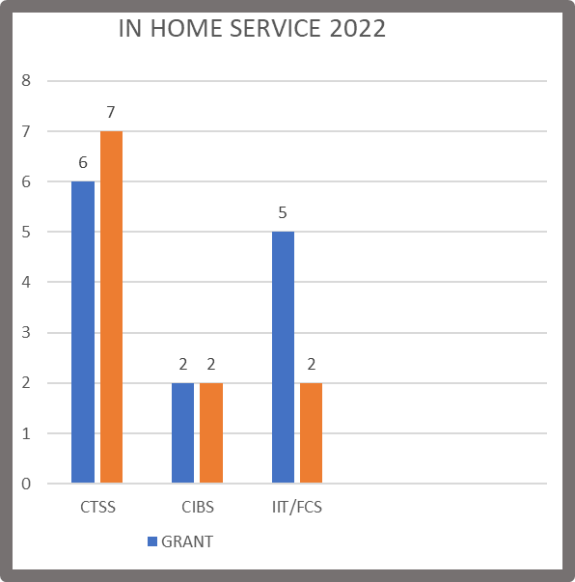

|  |  |  |  |  |
| --- | --- | --- | --- | --- |
| **CURRENT CASE MANAGEMENT** | | | | |
|  | **Case Mgr #1** | **Case Mgr #2** | **Case Mgr #3** | **TOTAL** |
| # People serving | 28 (1 in assess) | 45 (2 in assess) | 42 (2 in assess) | 115 |
| # on DD Waiver | 22 | 37 | 33 | 92 |
| # on CADI Waiver | 4 | 4 | 0 | 8 |
| # on BI Waiver | 1 | 0 | 0 | 1 |
| # Rule 185 w/service | 1 | 2 | 9 | 12 |
| ‘22 Waiver Revenue | $87,419.80 | $88,615.00 | $83,143.00 | $259,177.80 |
| Qtr 1 ’23 Wvr Revenue | $21,267.00 | $29,800.00 | $23,074.00 | $74,141.00 |
| Workgroups opened | 3 | 8 | 8 | 19 |
| Workgroups closed | 4 | 4 | 2 | 10 |
| Range of billable hours | 130.25 to 8.25 | 104.25 to 1.25 | 75.75 to 14 |  |
| Avg billable hrs/per/yr | 34.3 | 24.45 | 28.15 |  |
| Children in placement | 1 | 3 | 0 | 4 |

*Adult and Disability Unit*



*Investigations*

|  |  |  |  |  |  |
| --- | --- | --- | --- | --- | --- |
| County APS Agency | 2019 | 2020 | 2021 | 2022 | WPHS Total |
| Agency Reports | 122 | 133 | 70 | 117 | 442 |
| Accepted for  Investigation/Services | 55 | 53 | 31 | 45 | 184 |
| %Accepted for  Investigation/Services | 86% | 83% | 108% | 74% | 86% |

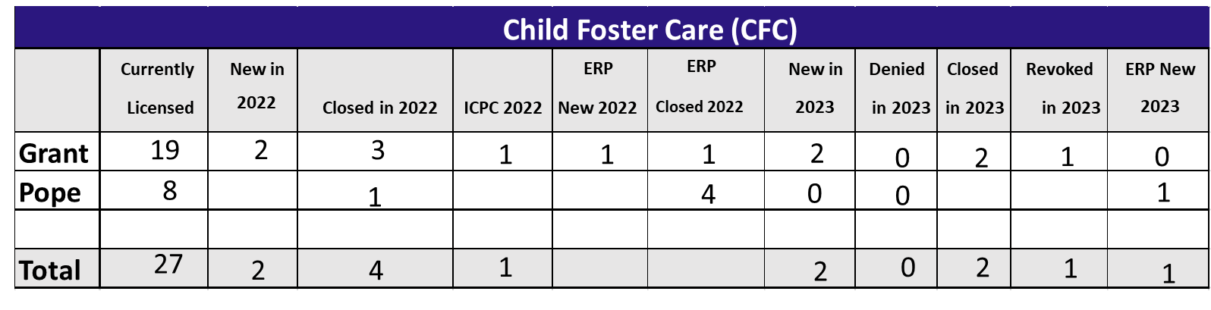

|  |  |  |  |
| --- | --- | --- | --- |
| WPHS Adult Foster Care Licensing | | | |
| Current Licensed | W/245D | New in 2022 | Closed in 2022 |
| 7 | 5 | 2 | 0 |
| Corporate Residential Setting | | | |
| 10 | 1 | 2 | 0 |

Fiscal Unit

|  |  |
| --- | --- |
| MA CHILD TOTAL | 260,977.00 |
| MA ADULT TOTAL | $118,806.35 |
| PW CHILD TOTAL | $380,384.50 |
| PW ADULT TOTAL | $256,357.43 |
| Grand Total | $1,016,525.28 |

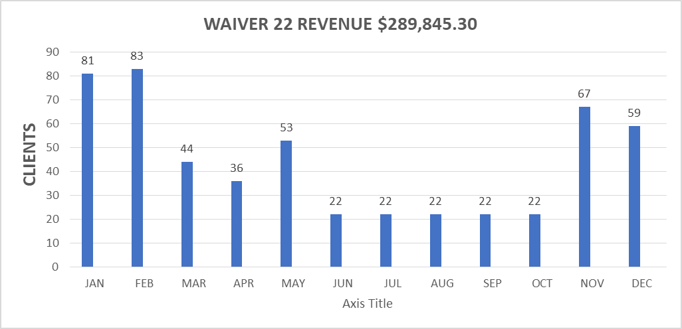

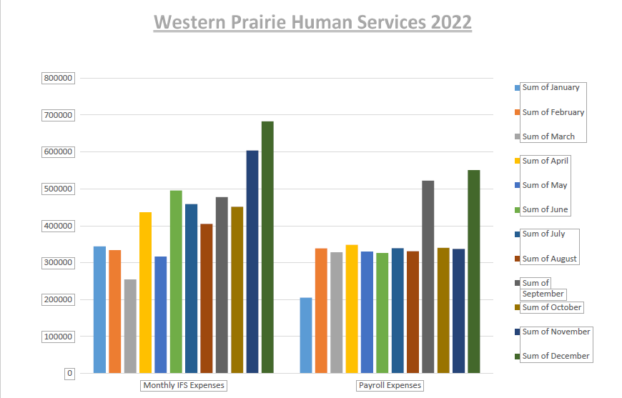

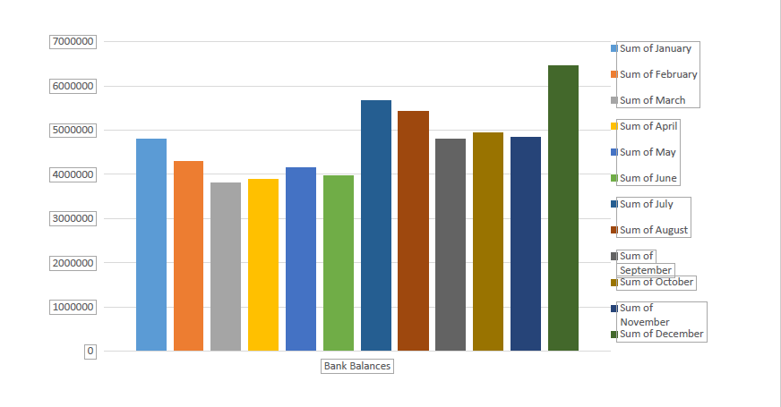

|  |  |  |  |  |  |
| --- | --- | --- | --- | --- | --- |
|  |  | Jan.-Dec. 2022- 100% of Budget | 2022 Budget | |  |
| % of Budget | | |
| Income Maintenance | Revenue | ($ 2,993,322.29) | ($ 2,584,046.00) | 116% | |
|  | Expenses | $ 2,359,524.42 | $ 2,311,812.00 | 102% | |
| Social Services | Revenue | ($ 5,582,287.97) | ($ 5,558,564.00) | 100% | |
|  | Expenses | $ 5,380,666.11 | $ 5,783,066.00 | 93% | |
| ARPA | Revenue | ($ 24,211.06) | $ - |  | |
|  | Expenses | $ 24,311.06 | $ - |  | |
| Trans. Housing | Revenue | ($ 5,000.00) | $ - |  | |
|  | Expenses | $ 4,099.55 | $ - |  | |
| MH Transp. | Revenue | ($ 7,200.00) | $ - |  | |
|  | Expenses | $ 4,517.19 | $ - |  | |
| MH FLEX | Revenue | ($ 3,900.00) | $ - |  | |
|  | Expenses | $ 2,858.49 | $ - |  | |
| Area on Aging | Revenue | ($ 70,450.08) | ($ 62,266.00) | 113% | |
|  | Expenses | $ 98,154.86 | $ 109,998.00 | 89% | |
| TOTAL FUND 11 | Revenue | ($ 8,686,371.40) | ($ 8,204,876.00) | 106% | |
|  | Expenses | $ 7,874,131.68 | $ 8,204,876.00 | 96% | |
|  |  | ($ 812,239.72) | $ - |  | |